*How Does a Four Cycle Gasoline Engine Work?*

How a four cycle gasoline engines works is broken down into 4 parts. Intake, compression, power and exhaust.

* Intake: This is when the stroke or the movement of the piton begins at the top and ends at the bottom. In this stroke the intake valve is opened. This creates a vacuum as the piston goes down causing an air/fuel mixture to enter into the cylinder. 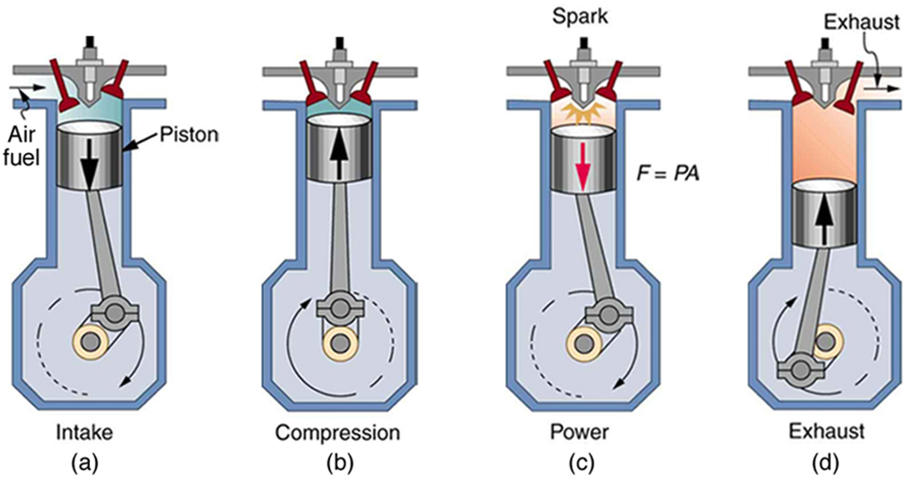
* Compression: This stroke begins at the bottom and ends at the top. The piston compresses the air/fuel mixture to prepare for the ignition. Both intake and exhaust valves are closed.



Piston Head

* Power/Energy: At this point the crankshaft *(A part able to perform a rotational motion)* has completed a full 360 $°$ revolution. The piston, now at the top again because of the Compression cycle and the compressed air/fuel mixture is ignited by a spark plug*(device for delivering electric current from an ignition system to the combustion chamber of a spark-ignition engine to ignite the compressed fuel/air mixture by an electric spark),* forcefully returning the piston to the bottom. This stroke produces mechanical work from the engine to turn the crankshaft.



* Exhaust: During the exhaust phase the piston returns to the top while the exhaust valve is open. This action ejects the spent air-fuel mixture through the exhaust valve.



The sensors inside your car.

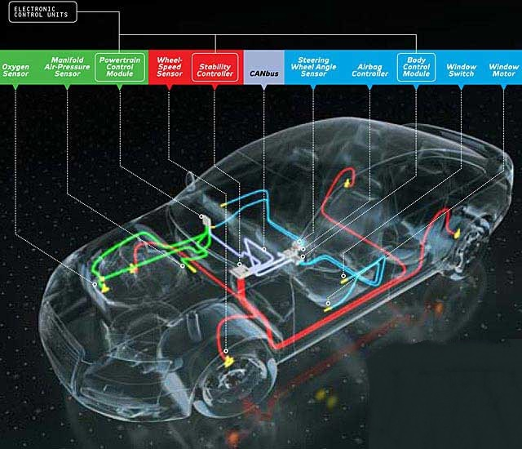

*Electronic Control Unit:*

The ECU is the computer inside of a car. It relies on a closed loop and the inputs from sensors located all around the car to adjust engine performance, emissions and other functions. The sensors must give the ECU accurate information otherwise it will result in emission failures, extra fuel consumption and problems while driving. As shown in the picture above there are many types of sensors in a modern day car. The ECU uses a closed-loop control *(which is when for example the oxygen sensor sends a reading to the ECU that too much fuel is being used and thus the ECU will change the ratio. This will produce a change in the O2 sensor reading. This is a closed loop because the ECU relies on the O2’s sensor reading).* The ECU knows everything from the coolant temperature to the amount of oxygen in the exhaust. With this data, it performs millions of calculations each second, including looking up values in tables, calculating the results of long equations to decide on the best [spark timing](http://auto.howstuffworks.com/ignition-system.htm) and determining how long the [fuel injector](http://auto.howstuffworks.com/fuel-injection.htm) is open.

*Oxygen Sensor:*

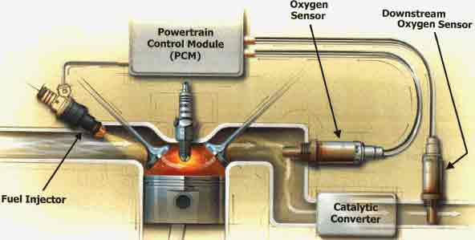

One key sensor that all cars have is the oxygen sensor or the O2 sensor. It is practically mandatory to have one on a car since federal emission laws wanted to cut back on the CO2 production, and now many vehicles are equipped with multiple O2 sensors, sometimes as many as 4. The O2 sensor is usually mounted on the exhaust to monitor how much unburned oxygen is the smoke coming out of the exhaust as it leaves the engine. By monitoring the oxygen level on the mixture, it can tell the ECU that the mixture is burning rich (lees oxygen, more fuel) or lean (more oxygen less fuel). There are other sensors to monitor these factors, too, but the O2 sensor is the master monitor for what's happening with the fuel mixture. Consequently, because of the reading from the O2 sensor, the ECU will change the amount of fuel or oxygen it’s burning. The ideal stoichiometric ratio is 14.7:1.

*Stoichiometric Ratio:*

This ratio represents the ideal amount of air and fuel to produce a complete combustion event. For gas engines its 14.7 parts of air to 1 part of fuel.

*M.A.P. Sensor:*

M.A.P. sensor stands for Manifold Absolute Pressure Sensor. It senses the pressure and applies the right amount of gas with the right ignition time so the car runs smoothly. If this does not work properly, it kills the loop cycle (described above) for the ECU which then causes the car to get bad mileage and poor fuel economy. It will also give poor take offs meaning your engine will have trouble starting and will occasionally stall. The M.A.P. Sensor is key for the ECU to run efficiently.

*Throttle Position Sensor:*

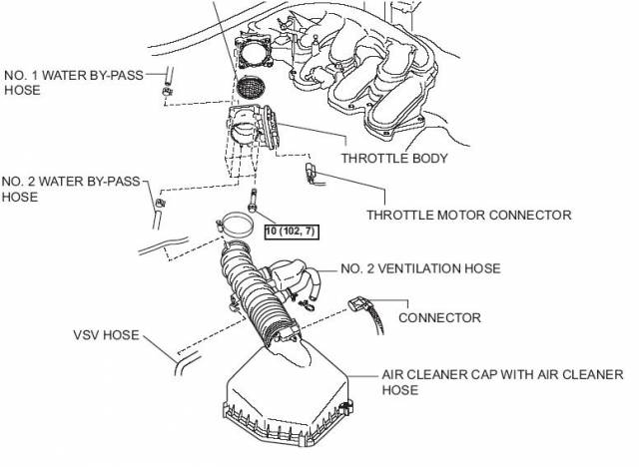

For a car to run efficiently it needs the right mixture of fuel and air. The amount of air in the engine is controlled by the air intake system. A throttle body is part of the fuel intake system that controls the amount of air that gets into the engine. The throttle body also has a plate which opens and closes. When you push the gas pedal the plate opens allowing air to get into the engine. The amount of air that gets into the engine is determined by how much you push the pedal. The more you push, the wider the plate opens, the more air will flow into the engine meaning more power and speed. The throttle position sensor reports the position (angle) the gas pedal is at and reports it to the ECU which then determines the amount of air that flows into the engine and the amount of fuel to be injected for the required Air-Fuel Mixture. This is key for the car as it is the way that air gets to the engine for the combustion even occurs.

*Anti-Lock Braking Sensor/Wheel Speed Sensor:*

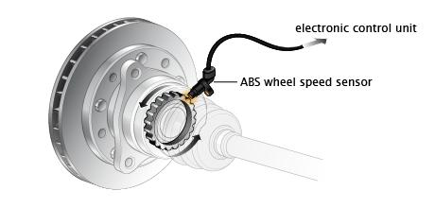The sensor is attached to the brake rotor and is connected to the ECU and monitors the changes in velocity of the 4 wheels. If the computer detects that a wheel is rotating at a different speed from the rest it will reduce the fluid pressure in the brake, freeing the wheel and/or activate the antilock braking system which prevents the wheels from locking up and skidding.

*Engine Speed sensor:*

Are attached to the crankshaft of a car’s engine, its main purpose is to measure how fast a crankshaft spins. The information from the crankshaft sensor is used to control the engine management and the ignition timings.

In conclusion, the ECU is basically the motherboard of the car, everything leads back to it and without it the car would never run as well as it does now. The ECU controls all the sensors and ensures the car is running at optimal capacity.

*Bibliography*

<http://www.popularmechanics.com/cars/how-to/a7386/how-it-works-the-computer-inside-your-car/>

<https://www.google.ca/search?q=What+is+the+oxygen+sensor+on+a+car%3F&rlz=1C1CHZO_enCA662CA663&oq=What+is+the+oxygen+sensor+on+a+car%3F&aqs=chrome..69i57&sourceid=chrome&es_sm=93&ie=UTF-8>

<https://www.google.ca/webhp?sourceid=chrome-instant&ion=1&espv=2&ie=UTF-8#q=Oxygen+sensor&safe=active>

<http://www.autotap.com/techlibrary/understanding_oxygen_sensors.asp>

<https://www.google.ca/search?q=Antilock+Brake+System+sensor&espv=2&rlz=1C1CHZO_enCA662CA663&biw=1280&bih=879&source=lnms&sa=X&ved=0CAYQ_AUoAGoVChMIiJ_mrKXRyAIVAaMeCh2yew2p&dpr=1>

<https://en.wikipedia.org/wiki/Air%E2%80%93fuel_ratio>

<http://www.carsdirect.com/car-repair/what-an-engine-speed-sensor-does>

<http://www.brakeandfrontend.com/steering-position-sensors-keeping-on-track/>